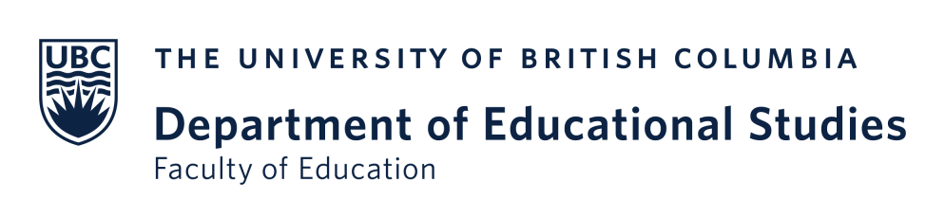

Formative Peer Review of Teaching for Sessional Lecturers:
Recommended Procedure for Obtaining Student Feedback

Ideally, after the sessional lecturer has been hired but before the term starts:
- The Deputy Head and/or the Administrative Manager are in touch with the Teacher Education Coordinator and the ADHE Course Coordinator about upcoming peer reviews.
- Course Coordinators can contextualize the recommendation that sessional instructors obtain student feedback via Canvas as part of the review process (e.g., that obtaining student comments on teaching early on is good pedagogical practice, that they will control the process and can choose whether and how to share the feedback with the peer reviewer).
Once the Canvas shell for the course is available and the sessional lecturer is adapting it:
- Use the “Quizzes” feature in Canvas to create a short, anonymous survey
- Choose a “quiz engine”: Select “classic quiz.”
- Guidelines:
  - DETAILS TAB:
  - Title the quiz:
    - Learner Experience Survey: The First Few Weeks
    - Early Course Check-In
  - Create a preamble (aka “Quiz Instructions”):
    - “We are a few weeks into the term, and I would value your feedback on what has worked well so far and what might be improved going forward. I have made the "quiz" anonymous. There are 2 open-ended questions. Your responses will not be graded; they will help me think about what I might do to make the course better. This is an optional task for this course.”
    - Feel free to adapt the above language to fit your particular course.
  - Check off these parameters:
    - Quiz type: Ungraded survey
    - Options: Keep submissions anonymous
    - Options: Allow multiple attempts (latest)
    - Assign to: Everyone
    - Due: Figure out a time before the peer review begins (e.g., week 4) & select a date and time
    - Available from: select a date about a week or so before your due date
  - QUESTIONS TAB:
  - New Question: Select “Essay question”
    - Question 1: What has gone well in the class so far?
    - Question 2: Suggestions for improvement?
- Publish the quiz within Canvas and direct your students to take it during the time period you have set; consider giving them 5 or 10 minutes to do this during class
During the initial meeting between the peer reviewer and the sessional lecturer:
- Come to an agreement on (a) whether the sessional lecturer will solicit student feedback and (b) if so, how to share the results (e.g., sharing survey results, summarizing student feedback).

The online MEd in Adult Learning and Global Change (ALGC) uses a learning management system (LMS) at Linköping University in Sweden rather than Canvas and sessional lecturers teach both UBC and non-UBC students. Therefore, soliciting student feedback early in ALGC courses will have to be done through Linköping’s LMS.

