

**Leadership for Indigenous Education**

**Please join us for this symposium that presents**

**Indigenous perspectives and facilitates dialogue**.

**Friday October 25, 2013 - 1:00 – 4:30 PM**

**UBC Robson Square - Theatre Room C300, Downtown Vancouver**

Keynote Presenters:

Dr. Jaqueline Ottman, University of Calgary

In this session the following questions will be addressed: What are Indigenous leadership and education, and the relationship between leadership and education? Why is leadership for Indigenous education important for all educators/learners? How can a graduate educational program address leadership for Indigenous education? Professional and personal experiences, challenges and successes with leadership for Indigenous education will also be shared by Dr. Ottmann.

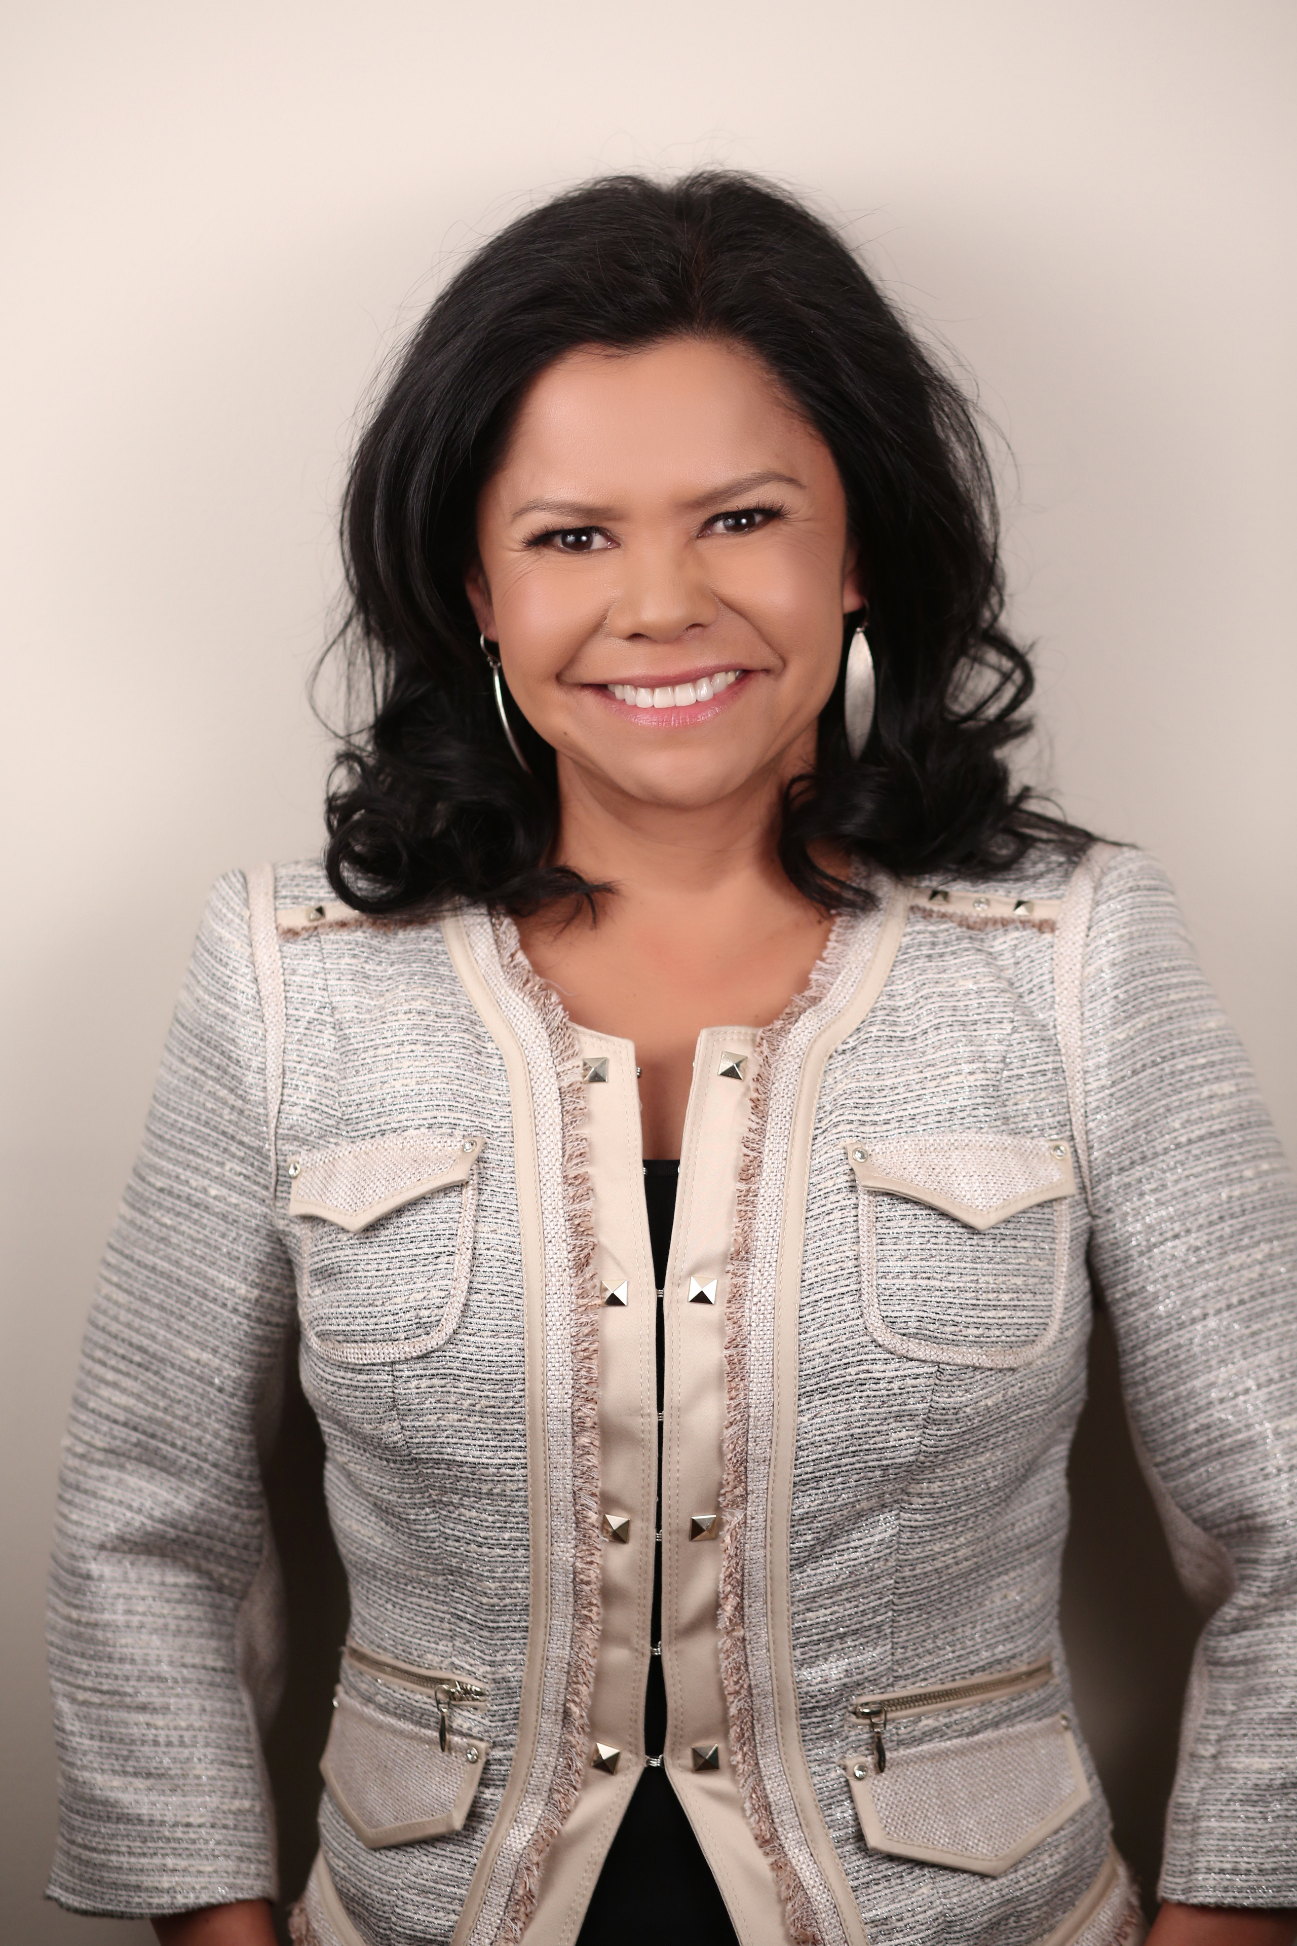Bio for Dr. Jacqueline Ottmann

After elementary and secondary teaching in public, separate, and private systems in Saskatchewan and Alberta, and a principalship, Jacqueline entered a University of Saskatchewan graduate program where she earned a M.Ed. degree and a Ph.D.; the research focus was on First Nations spirituality and leadership, and First Nations leadership development. Dr. Ottmann is currently Associate Professor at the University of Calgary in the Faculty of Education. In this context, Dr. Ottmann has also been active in research and publications that focus on Indigenous education and leadership. Jacqueline has presented at educational conferences and established collegial and collaborative scholarly and educational relationships in Canada, the United States, New Zealand and Australia.

Dr. Verna Billy-Minnabarriet, Nicola Valley Institute of Technology

This session will share highlights of her research and professional experience working with Indigenous post-secondary institutes in British Columbia. She will focus on the leadership role and impact of Indigenous community members, Elders, and faculty related to governance, policy, teaching, and student services at the only public Indigenous post-secondary institution in British Columbia, the Nicola Valley Institute of Technology. She will also discuss the leadership role of a provincial organization, the Indigenous Adult and Higher Learning Association, in improving Indigenous post-secondary education.

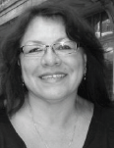Bio for Dr. Verna Billy-Minnabarriet

Dr. Verna Billy-Minnabarriet was born and raised in the small community of Cache Creek. She is a member of the Bonaparte Indian Band, located 88km north of Kamloops, BC. Verna completed her B.A. and M.A degrees at Simon Fraser University and a Doctorate of Education in Leadership & Policy from the University of British Columbia. Verna is the Vice President at the Nicola Valley Institute of Technology (NVIT) in Burnaby, BC. Previously, Verna was an instructor for NVIT (Merritt campus), the Community Futures Development Corporation of Central Interior First Nations, and the Native Adult Instructors Diploma Program, where she also assisted in the design, development, and implementation of the program. Her expertise as a contractor, business women, educator and professional has lead her to represent many First Nation’s organizations at all levels of Government.

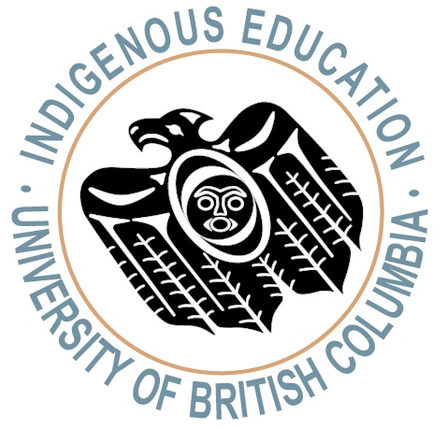**RSVP to roweena.bacchus@ubc.ca for catering purposes by October 16, 2013**

Sponsors: The Office of Indigenous Education, Educational Administration and Leadership program, Ed.D. in Educational Leadership and Policy in the UBC Faculty of Education